Title
Author*, Author, Author³

Abstract
You must first apply to our conference by submitting an abstract. Abstracts should be written in English as a single paragraph and should be between 250 and 400 words. The abstract should briefly include the aim, method, main findings, and contribution of the study. Tables, figures, citations, and references should not be included in the abstract. Abstracts should be checked for grammar, spelling, and punctuation before submission and must be submitted in Word (.docx) format.

Keywords: Keyword 1, Keyword 2, Keyword 3, Keyword 4, Keyword 5, Keyword 6

1. INTRODUCTION

- Throughout the full-text paper, the first paragraph under each main section heading should begin without indentation, while subsequent paragraphs should begin with paragraph indentation.
- Abbreviations should be written out in full when they first appear in the text, followed by the abbreviation in parentheses. The abbreviation may be used alone in subsequent occurrences.
- Attention should be paid to spelling, grammar, and punctuation rules.
- The full-text paper should be written in an academic, clear, and understandable style, using third-person language.
- Sentences should be simple and clear, avoiding unnecessary length and complexity.
- Headings and subheadings should be formatted according to the rules specified in the template.
- The terminology used in the text should be consistent; different terms should not be used for the same concept.
- Tables, figures, and graphs should be numbered sequentially and referred to appropriately within the text.
- Table captions should be placed above the tables, while figure and graph captions should be placed below the visuals.
- Text used in tables, figures, and graphs should be legible, and low-resolution visuals should not be used.
- In-text citations and the bibliography should conform to the citation style specified in the template, namely APA 7th edition.
- All sources cited in the text should be included in the bibliography, and all studies listed in the bibliography should be cited in the text.
- Direct quotations should be placed in quotation marks and cited appropriately.
- The aim, method, findings, and conclusions of the study should be clearly stated.
- Personal, informal, or non-scientific expressions should be avoided in the full-text paper.
- Numbers, units, symbols, and formulas should be used consistently and in accordance with scientific writing rules.
- Consistency should be maintained throughout the text in decimal notation, units of measurement, and statistical expressions.
- Before submission, the text should be carefully checked for grammar, spelling, formatting, and bibliography accuracy.
- The page limit, font type, font size, line spacing, margins, and file format rules specified in the template must be followed.

For an example of the full-text paper format, authors are encouraged to review our conference thematic book available through the link below: https://press.gedik.edu.tr/kitaplar/rhythm-of-nature-transition-of-energy-power-of-production

2. SECTION TITLE

  - Subtitle

  - Subtitle

  - Subtitle

3. SECTION TITLE

3.1 Subtitle

3.2 Subtitle

3.3 Subtitle

4. SECTION TITLE

4.1 Subtitle

4.2 Subtitle

4.3 Subtitle

…
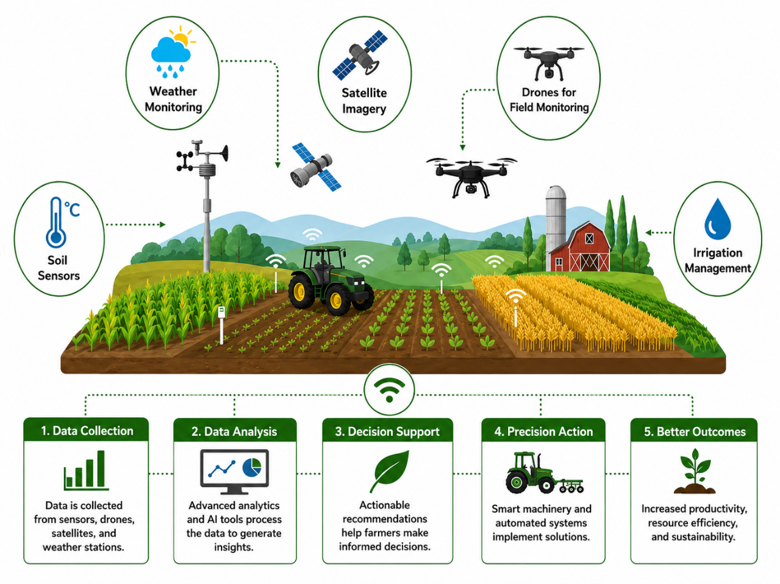
Figure 1. Figure Title

Table 1. Table Title
Times New Roman (10) | Times New Roman (10) | Times New Roman (10)
Times New Roman (10) | Times New Roman (10) | Times New Roman (10)
Times New Roman (10) | Times New Roman (10) | Times New Roman (10)
Times New Roman (10) | Times New Roman (10) | Times New Roman (10)
Times New Roman (10) | Times New Roman (10) | Times New Roman (10)

6. CONCLUSION

Acknowledgements

Funding

Declaration of Competing Interest
Appendix
A. Appendix Title
B. Appendix Title

REFERENCES
For detailed information about the APA 7 referencing style, please review the relevant section on the page linked below: https://etsc.gedik.edu.tr/submission/

Affiliation, City, Country, e-mail address, ORCID:
Affiliation, City, Country, e-mail address, ORCID: Affiliation, City, Country, e-mail address, ORCID: * Corresponding Author

